# CHAPTER – 1INTRODUCTION TO PROJECT

The computerized **On-Line Banking System** is for the management of Accounts, Customers and their Transactions (Deposit/Withdraw) with the help of computer.

## 1.1 Description

In"this venture we can keep record of every day banking exchanges. This undertaking is fit for holding any quantities of records. In first choice we can see record of a specific individual by giving essentially account number of that individual. In subsequent choice we can see the rundown all things considered. Through third alternative we can do banking exchanges (store/pull back) in fourth choice we can open new account. In the fifth choice we can alter or erase any record and last choice is stopped to leave the undertaking.”

The project maintains multiple accounts and customer details on-line. The project also maintains details for various account number and password assigned to them. A customer can login by entering account number and password to perform various types of transactions such as view the balance, deposit the amount and withdraw the amount and other activities.

## 1.2 Objective

Our project performs these tasks by using computer. In this project we first records list of all the Accounts along with their address and password to use through the net. When a new account is created then we store the detail of the customers with their personal details. Each customer is assigned a unique account number & password for future reference. The customer can perform different types of transactions such as deposit the amount and withdraw the amount. The customer can also transfer the amount from one account to another.

# CHAPTER – 2 SYSTEM STUDY

## 2.1 Existing System

In the fast growing world the information is needed as fast as possible. This can be accomplished by passing the information quickly. The normal banking system requires customers to visit the bank for different banking operations such as creating new account, deposit or withdraw of amount. It is time consuming and costly. Also we need various forms to perform various transactions. So we need a system that performs these tasks quickly. Also we can perform these operations without going to the bank.

Convenience,“control and cost savings are the three primary motivators that drive consumer adoption of online banking. These online bankers want to conveniently access their financial information and conduct activity anytime, anywhere.”

## 2.2 Proposed System

Our aim is to develop an online banking system which can support various facilities to enable its viewers the desired purpose.

* This project enables the users to sit at their home and get information related to their bank accounts, about balance, about cards etc.
* It enables the banks to do less paper work and also it reduces burden on them.
* It can be used by many users at the same time.
* Account Holders or Customers can transfer the amount to another account easily & securely.

## 2.3 Feasibility Study

In"this venture we can keep record of every day banking exchanges. This undertaking is fit for holding any quantities of records. In first choice we can see record of a specific individual by giving essentially account number of that individual. In subsequent choice we can see the rundown all things considered. Through third alternative we can do banking exchanges (store/pull back) in fourth choice we can open new account. In the fifth choice we can alter or erase any record and last choice is stopped to leave the undertaking.”

**ECONOMIC FEASIBILITY:**

In economic feasibility, which is also known as the Cost Benefit Analysis, costs are compared for systematic development and implementation over the outcomes and benefits of the system. Here the benefit expected from the system is compared with the cost.“If the benefits outweigh costs, then decision is made to design and implement the system.”**ONLINE BANKING SYSTEM** has many advantages over the manual system, and the most important of these advantages is that it will minimize the human efforts. The benefits derived from the system are expected to be much more than the cost, and so we accept it economically feasible.

**TECHNICAL FEASIBILITY:**

Technical feasibility centers on the existing computer system (hardware, software etc.) and to what it can support the proposed system. Under this consideration it is to be examined as to whether the existing hardware and software is enough to carry out the system. The hardware as well as the software resources required developing and implementing the software for the **ONLINE BANKING SYSTEM** is presently available. So the proposed system can be regarded as technically beneficial.

**BEHAVIORAL FEASIBILITY:**

In“general people are resistant to change and computers have been known to facilitate change. It is a common notion that computer installation APR lead to transfers, turn-over, re-training and changes in the employee status. Therefore, it is understandable that the introduction of the **ONLINE BANKING SYSTEM** would require special efforts to educate and train the staff on new ways of conducting business. Presence of a large number of computerized systems, people are very much familiar with computers and because of this the proposed system is considered to behaviorally feasible.”

**OPERATIONAL FEASIBILITY:**

Proposed projects are valuable only if they can be turned into information systems that will meet the organizations functional requirements. Simply settled, this test of viability asks if the system will work when it is developed and installed.

# CHAPTER –3 Project Monitoring System

We can monitor the progress of software project using Gantt chart

## 3.1 Gantt chart

Gantt“Charts are venture control procedure that can be utilized for a few purposes, including booking, planning and asset arranging. A Gantt outline is a bar graph, with each bar speaking to a movement. The bars are drawn against a course of events. The length of each bar is relative to the period of time made arrangements for the action.

During the booking action and furthermore during execution of the undertaking, new exercises APR be recognized that were not imagined during the underlying arranging. The engineer should then return and update the breakdown structure and the calendars to manage these new exercises.”

We estimated the number of weeks required for each of the seven tasks as follows:

Analysis 1 Weeks

Design 2 Weeks

Coding 3 Weeks

Testing 2 Days

Write Manual 2 Days

Implementation 1 Day

Maintenance 2Days

Detail schedule of activities are listed in the Gantt chart shown in figure below.

|  |  |  |  |  |  |  |  |
| --- | --- | --- | --- | --- | --- | --- | --- |
| **Activities** | 20-JUN TO 27-JUN | 28-JUN TO 11-JUL | 12-JUL TO 03-AUG | 04-AUG TO 06-AUG | 07-AUG TO 09-AUG | 10-AUG | 11-AUG TO 12-AUG |
| **PROBLEM ANALYSIS** |  |  |  |  |  |  |  |
| **DESINING** |  |  |  |  |  |  |  |
| **CODING** |  |  |  |  |  |  |  |
| **TESTING** |  |  |  |  |  |  |  |
| **WRITE MANUAL** |  |  |  |  |  |  |  |
| **IMPLEMENTATION** |  |  |  |  |  |  |  |
| **MAINTAINANCE** |  |  |  |  |  |  |  |

##### Table3.1: GanttChart

# CHAPTER –4 Software Requirement Specification

## The“Software Requirements Specification is delivered at the climax of the investigation task. The capacity and execution distributed to programming as a feature of framework building are refined by setting up a total data portrayal, a point by point practical depiction, a portrayal of framework conduct, a sign of execution prerequisites and structure limitations, proper approval criteria, and other data relevant to necessities. The National Bureau of Standards, IEEE (Standard No. 830-1984), and the U.S. Division of Defense have all proposed competitor groups for programming prerequisites details (just as other programming designing documentation).”

## 4.1 Introduction

The Introduction of the product prerequisites detail expresses the objectives and goals of the product, portraying it with regards to the PC based framework. All things considered, the Introduction might be just the product extent of the arranging archive. The Information Description gives a nitty gritty depiction of the issue that the product must fathom. Data substance, stream, and structure are archived. Equipment, programming, and human interfaces are depicted for outer framework components and inward programming capacities.

A depiction of each capacity required to take care of the issue is exhibited in the Functional Description. A preparing story is accommodated each capacity, plan requirements are expressed and defended, execution attributes are expressed, and at least one outlines are incorporated to graphically speak to the general structure of the product and exchange among programming capacities and other framework components. The Behavioral Description segment of the determination looks at the activity of the product as an outcome of outside occasions and inside created control attributes. Approval Criteria is likely the most significant and, unexpectedly, the regularly ignored segment of the Software Requirements Specification. How would we perceive an effective execution? What classes of tests must be directed to approve capacity, execution, and limitations? We disregard this segment in light of the fact that finishing it requests an exhaustive comprehension of programming necessities—something that we regularly don't have at this stage. However, particular of approval criteria goes about as a verifiable survey of every other prerequisite. It is basic that time and consideration be given to this area.

## 4.2 Software Requirement

* **Operating System: Windows XP, Windows 7 or Later**

The system will be built on windows compatible environment. The application will be web based developed using Java technology.

* **Server side Application Software**: PHP
* **Client Side Application Software**: JavaScript
* **Data Base**: MYSQL

## 4.3 Hardware Requirements:

* **Processor:** Intel Pentium III or higher
* **HDD:** 80GB or more
* **RAM:** 1GB or more
* Keyboard, Mouse, Monitor

**GUI Tools and its Importance:**

Graphical User Interface helps users to interact graphically with the computer i.e. a user can use different graphical capability such as text, mouse and picture to communicate with the computer.

The GUI divided into following types:

**1. Front-End:** The end is visible to the user and responsible for interactive with the user. The front end is responsible for receiving user’s queries, passing it over to the backend. The front–end includes graphical user interface. Apart from the user interface, the frond-end also contains database objects that form a layer between the user interface and the backend. Ex: Java, C#, VB, VC++, PHP.

**2. Back-end:** This end is not visible to the user but it performs all database–related tasks in the background. It receives user’s queries and passes them to the database server. After processing the user’s requests and queries, the server returns the results to the backend that passes it to the front-end. Ex: MS-ACCESS, ORACLE, MYSQL

**Importance of GUI Application:**

1. It is user friendly

2. It frees user from the internal working of the system.

3. It performs maximum of work, while requiring a minimum of information from users.

4. Its design is aesthetic.

**PHP**

PHP “(Hypertext Preprocessor) was released in the 1995. PHP was originally known as Personal Home Page written as a set of Common Gateway Interface (CGI) in C Language by Danish/Greenlandic programmer RasmusLerdorf.Lerdorf initially created these Personal Home Page Tools to replace a small set of Perl scripts he had been using to maintain his personal homepage and was originally designed to replace a set of Perl scripts to maintain his Personal Home Pages (also known as PHP) in 1994. He combined these with his Form Interpreter to create PHP/FI, which had more functionality. PHP/FI included a larger implementation for the C programming language and could communicate with databases, enabling the building of simple, dynamic web applications. Lerdorfreleased PHP publicly on June 8, 1995 to accelerate bug location and improve the code. This release was named PHP version 2 and already had the basic functionality that programming php has today.””

PHP versions till date (php info):

* PHP 2 starting from 1995
* PHP 3.0.0 to 3.0.17 starting from 1997
* PHP 4.0.0 to 4.0.6 , 4.1.0 to 4.1.2 , 4.2.0 to 4.2.3 , 4.3.0 to 4.3.11 , 4.4.0 to 4.4.9 starting from 2000
* PHP 5.0.0 to5.0.5 ,5.1.0 to 5.1.6 , 5.2.0 to 5.2.11 , 5. 3.1 starting from 2004
* PHP 6.0.0

All“major operating systems including Linux, Microsoft Windows, Mac OS X, and RISC OS, you can use PHP in all these operating systems. As you know there is procedural programmingor object oriented programming. PHP uses either procedural programming or object oriented programming. Also you can mix them and use both (procedural programming and object oriented programming). As i mention above, PHP is used mainly in server-side scripting, command line interface and writing desktop applications. PHP also supports ODBC, the Open Database Connection standard which allows you to connect to other databases supporting this world standard. For database, phpMyAdminis most widely used for PHP development. Server-side scripting is the most traditional one for PHP development. In order to use PHP for server-side scripting you need.”

1. PHP parser

2. Web server

3. Web browser.

The“PHP codes entered with the parser on a web server will be translated into a PHP page that can be viewed on your web browser. Main reason behind popularity of PHP language is, it can be embedded directly into HTML coding. It has more benefits such as the following”

1. “It can be used on all major operating systems.”  
2. “It can be supported by most of the web servers.”  
3. “The latest version of PHP development is a very stable and grown-up language used for web programming like Java and C#.”

Both“the PHP engine and the PHP code can be used on any platform, which makes PHP extremely flexible. PHP has many features designed specifically for use in websites. PHP can be used to make your website secure by implementing mandatory sign in feature by asking the user or the administrator to enter a valid username and password. Adding such a feature is easy as PHP can display a HTML form and process the information that the user types in. This sign in feature can be an excellent way of getting to know about your customer's profile. The popularity of PHP Development continues to grow rapidly because it has many advantages over other programming language. PHP is fast because the time needed to process and load a webpage is relatively low. PHP is also versatile and it runs on a wide variety of operating systems. PHP hosting is a server-side scripting environment that is used to create dynamic web pages. It is an open source language which is widely used by programmers and web developers. Open source gives a lot of advantages over proprietary programming languages. Due to this reason, PHP has been the one of the most popular server-side scripting language so far. Almost all the hosting providers offer PHP hosting services these days. PHP is especially strong in relational databases, which are used for dynamic content and e-commerce applications. To know more about programming, php info, php editor, programming php, Open-source, php help and php script, subscribe to our feed by entering email address below. You will get updates via email about every tutorial posted on this site. It will not take more than a sec.”

**BACK-END**

Backend:“For processing and responding to the front-end requests, the backend maintains a database. A database is an organized collection of related information where organized means that data is stored in the form of rows and columns (table). A system that manages the database (i.e, to create the database, add records, delete records and modify the records) is called database management system (DBMS).”

**What is a database?**

Data Base is a set of tables and table is a collection of records in a tabular form i.e. in row and columns design.

In the above table, a row represents relationship b/w different set of values, so a table is also called a Relation. A row in the table is called tuple or record & a column in the table is called quality or field.

**RDBMS (Relational Database Management System):-**RDBMS“helps us to create & manipulate different types of databases or relations in the computer i.e. a user can insert, delete and modify records. Different types of RDBMS software available in the market are: ORACLE, My SQL, SQL SERVER.”

**MYSQL:** MYSQL is one of the leading RDBMS software created by MYSQL AB Corporation Ltd. It helps us to create & maintain different types of databases. Some common features of MYSQL are:

“

i. It helps us to create any type & size of database.

ii. It helps us to manipulate the table data i.e. we can insert, delete or modify any specific information from any specific table.

iii. It helps us to query the table for retrieving (displaying) any specific information from any specific database.

iv. It helps us to protect or share the table data with multiple users.

v. It helps us to maintain Data Dictionary & system catalog.

“

# CHAPTER –5 PROGRAM DESIGN

The processes of managing details of Accounts, Customers & Transactions (Deposit / Withdraw of amount) are performed by various modules in the project. The computerized Banking System helps us to quickly perform transaction. It helps us to find detail of any specific account, customer & account number and balance amount.

We are developing a Banking system. All the bank related aspects will be covered in this system which aims to the concept of “We are for you”. It is an extension of Banking System. It can be accessed by the admin department, bank’s employees, and the customers/ users.

The “requirements of this system will be met as stated below:

1. This is an online website that is it can be loaded on the Bank’s server.
2. The data will be stored on the MYSQL database which will be connected to the website.
3. On Admin front: The admin can maintain a list of account holders & their cards. It can also check the current status and cardinality of account holders. For all this to be implemented we require a security check so that no other non-privileged member gains access to this admin front. To accomplish this we have assign them passwords.
4. On customer’s front: The customer’s / end users can check the details of their accounts, about their balance, about their deposits and withdraws etc.

It provides fast and better access to up-to-date information.”

Main Modules of the Project are:

**Home Page**

* + This is the main page of the website containing information and hyperlinks
  + New user can create account with bank from home page itself by clicking

on register link.

**Registration Page**

* In this page new user may register him/her to with bank by filling his/her complete information along with identity card number.
* After filling all the information user gets registered with Bank and he/she gets the unique account number and password for login to the site.

**Login Page**

* User can get logged in by providing correct account number and password.
* Based on the login he is linked to the appropriate page. If the user is not given appropriated id and password, he will not be able to log in.

**Main Page**

After successfully login the main page of banking project will display. It shows current customer details such as account number, identity card number, full name and date of open the account by the customer.

All other functionality is performed through this page. From this page customer can do the following:

1. Check Balance
2. Deposit Amount
3. Withdraw Amount
4. Transfer Amount
5. Logout

## 5.1 Database Design of the Project

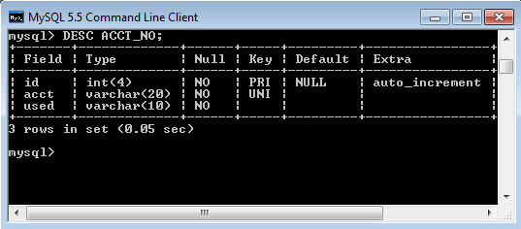**Table: Acct_No**

Fig 5.1: Acct no

**Table: LOGIN**

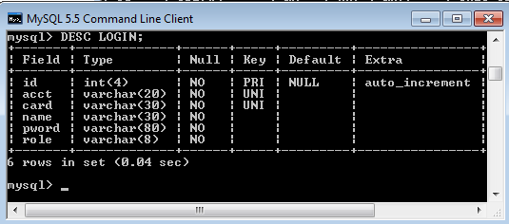

Fig 5.2:Login

**Table: EVENT**

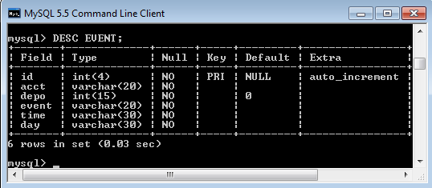

Fig 5.3: Event

**Table: MyAcct**

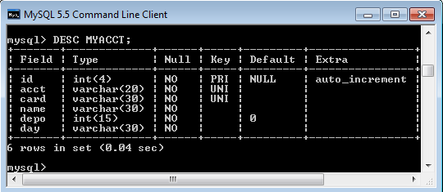

Fig 5.4: Myacct

## 5.2 Data Flow Diagram

Data“Flow Diagramming is a means of representing a system at any level of detail with a graphic network of symbols showing data flows, data stores, data processes, and data sources/destination. The data flow diagram is analogous to a road map. It is a network model of all possibilities with different detail shown on different hierarchical levels.

Details“that is not shown on the different levels of the data flow diagram such as volumes, timing, frequency, etc. is shown on supplementary diagrams or in the data dictionary. For example, data store contents may be shown in the data dictionary.

Data Flow Diagram (DFD) uses a number of symbols to represent the systems. Data Flow Diagram also known as ‘Bubble Chart’ is used to clarify system requirements and identifying the major transformations that will become programs in system design. So it is the starting point of the design phase that functionally decomposes the requirements specifications down to the level of details.”The following diagram illustrates the notations and symbols used to construct the DFD:

|  |  |
| --- | --- |
|  | A circle or bubble represents a process transform Incoming Data flow(s) into outgoing flows. |
| External Entity | A producer or consumer of information that resides outside the bounds to be modeled. |
|  | The arrowhead indicates the direction of flow. |
|  | The table in which information will be stored ultimately. |

##### Table 5.2: Data flow diagram

**DATA FLOW DIAGRAM:**

**BALANCE**

**ENQUIRY**

**MONEY**

**TRANSFER**

**LOGIN**

**MODULE**

**INTERNET**

**BANKING**

**Transaction MODULE**

**NEW CUSTOMER DATA**

**ACCOUNT**

**HISTROY**

**ACCOUNT**

**OPENING**

**ADMIN MODULE**

Fig 5.5: Data Flow Diagram

## 5.3 Detailed Description of Modules (Coding)

Main.php

<?php

session_start();

session_destroy();

?>

<html>

<head>

<title>Untitled Document</title>

<script language="JavaScript">

function validated()

{

var acct = document.s.acct.value;

varpword = document.s.pword.value;

if(acct==""){

window.alert("Please enter your account number!");

document.s.acct.focus();

return false;

}

if(pword==""){

window.alert("Please enter your password!");

document.s.pword.focus();

return false;

}

}

</script>

</head>

<body bgcolor='#333333'>

<br><br><br><br><br><br><br><br>

<form action='login.php' method='post' name='s' onsubmit='return validated()';>

<table width="50%" border="0" align="center" cellpadding="2" cellspacing="0" bgcolor="#000000">

<tr align="center">

<td colspan="3"><font color="#00FF00" size="1" face="verdana">Welcome to your Banking System!</font></td>

</tr>

<tr>

<td width="20%">&nbsp;</td>

<td width="61%">&nbsp;</td>

<td width="19%">&nbsp;</td>

</tr>

<tr>

<td>&nbsp;</td>

<td align="center"><font color="#00FF00" size="1" face="verdana">Account No.</font><br>

<input type='text' name='acct' size=30 maxlength=20></td>

<td>&nbsp;</td>

</tr>

<tr>

<td>&nbsp;</td>

<td align="center"><font color="#00FF00" size="1" face="verdana">Password</font><br>

<input type='password' name='pword' size=30 maxlength=10></td>

<td>&nbsp;</td>

</tr>

<tr>

<td>&nbsp;</td>

<td align="center"><input name="submit" type='submit' value='Login'>

<input name="reset" type='reset' value='Reset'></td>

<td>&nbsp;</td>

</tr>

<tr>

<td>&nbsp;</td>

<td align="center"><font color="#00FF00" size="1" face="verdana"><a href='register.php'><font color='#00FF00'>&lt;&lt;

Register here &gt;&gt;</font></a></font></td>

<td>&nbsp;</td>

</tr>

</table></form>

</body>

</html>

Db_connect.php

<?php

$host = '127.0.0.1';

$uname = 'root';

$pwd = '';

$db = "bank";

$con = mysqli_connect($host,$uname,$pwd, $db);

?>

Register.php

<html>

<script language="JavaScript">

function validated(){

var card = document.s.card.value;

var name = document.s.name.value;

varpword = document.s.pword.value;

var pword2 = document.s.pword2.value;

vardepo = document.s.depo.value;

vardepoint = parseInt(depo);

if(card==""){

window.alert("Please enter your identity card number!");

document.s.card.focus();

return false;

}

if(name==""){

window.alert("Please enter your name!");

document.s.name.focus();

return false;

}

if(pword==""){

window.alert("Please write your password!");

document.s.pword.focus();

return false;

}

if(pword2==""){

window.alert("Please write your password!");

document.s.pword2.focus();

return false;

}

if(pword !=pword2){

window.alert("Password not match!");

return false;

}

if(isNaN(depoint)){

window.alert("Please enter deposit!");

document.s.depo.focus();

return false;

}

if(depo< 200){

window.alert("Deposit must not less than $200!");

return false;

}

}

</script>

<body bgcolor='#333333'>

<br><br><br><br><br><br><br><br>

<form action='register_write.php' method='post' name='s' onsubmit='return validated()';>

<table width="50%" border="0" align="center" cellpadding="2" cellspacing="0" bgcolor="#000000">

<tr align="center">

<td colspan="3"><font color="#00FF00" size="1" face="verdana">Welcome to your Banking System!</font></td>

</tr>

<tr>

<td align="right">&nbsp;</td>

<td align="center">&nbsp;</td>

<td>&nbsp;</td>

</tr>

<tr>

<td width="22%" align="right"><font color="#00FF00" size="1" face="verdana">Identity Card </font></td>

<td width="4%" align="center"><font color="#00FF00" size="1" face="verdana">:</font></td>

<td width="74%"><input type='text' name='card' size=30 maxlength=30></td>

</tr>

<tr>

<td align="right"><font color="#00FF00" size="1" face="verdana">Full Name</font></td>

<td align="center"><font color="#00FF00" size="1" face="verdana">:</font></td>

<td><input type='text' name='name' size=30 maxlength=30></td>

</tr>

<tr>

<td align="right">PP<font color="#00FF00" size="1" face="verdana">Password</font></td>

<td align="center"><font color="#00FF00" size="1" face="verdana">:</font></td>

<td><input type='password' name='pword' size=30 maxlength=10><font color="#00FF00" size="1" face="verdana">max 10 digit</font></td>

</tr>

<tr>

<td align="right"><font color="#00FF00" size="1" face="verdana">Re-Enter Password </font></td>

<td align="center"><font color="#00FF00" size="1" face="verdana">:</font></td>

<td><input type='password' name='pword2' size=30 maxlength=10><font color="#00FF00" size="1" face="verdana">max 10 digit</font></td>

</tr>

<tr>

<td align="right"><font color="#00FF00" size="1" face="verdana">Deposit ($)</font></td>

<td align="center"><font color="#00FF00" size="1" face="verdana">:</font></td>

<td><input type='text' name='depo' size=20 maxlength=10><font color="#00FF00" size="1" face="verdana">min $200</font></td>

</tr>

<tr>

<td align="right">&nbsp;</td>

<td align="center">&nbsp;</td>

<td>&nbsp;</td>

</tr>

<tr>

<td>

<?php

$day=date("j M Y");

$time=date( "g:i:sa");

echo "<input type='hidden' name='day' value='$day'>";

echo "<input type='hidden' name='time' value='$time'>";

?>

</td>

<td align="center">&nbsp; </td>

<td><input name="submit" type='submit' value='Register'><input name="reset" type='reset' value='Reset'></td>

</tr>

</table>

</form>

</body>

</html>

Register_Write.php

<html>

<body bgcolor='#333333'>

<?php

include 'db_connect.php';

$sql = "SELECT * FROM acct_no WHERE used='no' order by id LIMIT 0,1";

$r = mysqli_query($con, $sql);

$row = mysqli_fetch_array($r);

if (mysqli_num_rows($r))

{

$acct = $row["acct"];

$card = $_POST["card"];

$name = $_POST["name"];

$pword = $_POST["pword"];

$depo= $_POST["depo"];

$time = $_POST["time"];

$day = $_POST["day"];

$sql2 = "INSERT INTO myacct(acct, card, name, depo, day)

VALUES ('$acct', '$card', '$name', '$depo', '$day')";

$result2 = mysqli_query($con, $sql2)

or die(" <script language='JavaScript'>

window.alert('Sorry, you already register!')

</script>

<meta http-equiv='REFRESH' content='0; url=register.php'>

");

$sql3 = "INSERT INTO login(acct, card, name, pword, role)

VALUES ('$acct', '$card', '$name', MD5('$pword'), 'user')";

$result3 = mysqli_query($con, $sql3)

or die("<script language='JavaScript'>

window.alert('Sorry, you already register!')

</script>

<meta http-equiv='REFRESH' content='0; url=register.php'>

");

$sql4 = "INSERT INTO event(acct, depo, event, time, day)

VALUES ('$acct', '$depo', 'Deposit', '$time', '$day')";

$result4 = mysqli_query($con, $sql4);

$sql5 = "UPDATE acct_no SET used = 'yes' WHERE acct = '$acct'";

$result5 = mysqli_query($con, $sql5);

if ($result5){

header("Location: register_preview.php?acct=$acct");

}

else{

die(mysqli_error($con));

}

}

else{

echo "<script language='JavaScript'>

window.alert('System error, Ask administration for further detail!')

</script>

<meta http-equiv='REFRESH' content='0; url=main.php'>";

}

?>

</body>

</html>

Login.php

<html>

<body bgcolor='#333333'>

<?php

session_start();

$acct=$_POST["acct"];

$pword=$_POST["pword"];

include 'db_connect.php';

$sql="SELECT * FROM login WHERE acct='$acct' AND pword=MD5('$pword')";

$result=mysqli_query($con, $sql);

$row = mysqli_fetch_array($result);

if (mysqli_num_rows($result))

{

$acct=$row["acct"];

$name=$row["name"];

$role=$row["role"];

$_SESSION['xacct']=$acct;

$_SESSION['xname']=$name;

$_SESSION['xrole']=$role;

header("Location: myacct.php");

}

else

{

mysqli_close($conn);

header("LOcation: main.php");

}

?>

</body>

</html>

Balance.php

<?php

session_start();

if ($_SESSION['xrole'] != 'user')

{

header("Location: main.php");

exit();

}

?>

<html>

<body bgcolor='#333333'>

<br><br><br><br><br><br><br><br>

<?php

include 'db_connect.php';

$xacct = $_SESSION['xacct'];

$sql = "SELECT * FROM myacct WHERE acct='$xacct'";

$result = mysqli_query($con, $sql) or die("SQL select statement failed");

while ($row = mysqli_fetch_array($result)) {

$acct=$row["acct"];

$depo=$row["depo"];

?>

<table width="50%" border="0" align="center" cellpadding="2" cellspacing="0" bgcolor="#000000">

<tr align="center">

<td colspan="3"><font color="#00FF00" size="1" face="verdana">Welcome to your Banking System!</font></td>

</tr>

<tr>

<td width="20%">&nbsp;</td>

<td width="61%">&nbsp;</td>

<td width="19%">&nbsp;</td>

</tr>

<tr>

<td>&nbsp;</td>

<td align="center"><font color="#00FF00" size="1" face="verdana">Account Number</font><br>

<font color="#00FF00" size="2" face="arial"><b><?phpecho"$acct"; ?><b></b></font><br></td>

<td>&nbsp;</td>

</tr>

<tr>

<td>&nbsp;</td>

<td align="center">&nbsp;</td>

<td>&nbsp;</td>

</tr>

<tr>

<td>&nbsp;</td>

<td align="center"><font color="#00FF00" size="1" face="verdana">Balance</font><br>

<font color="#00FF00" size="2" face="arial"><b>$ <?php echo"$depo"; ?></b></font><br></td>

<td>&nbsp;</td>

</tr>

<tr>

<td>&nbsp;</td>

<td align="center">&nbsp; </td>

<td>&nbsp;</td>

</tr>

<tr>

<td>&nbsp;</td>

<td align="center">

<table width="100%" border="0" align="center" cellpadding="2" cellspacing="0" bgcolor="#000000">

<tr><td align="right" width='70%'>

<form action='transaction.php' method='post'>

<input name="submit" type='submit' value='Check Transaction'>

</form>

</td><td width='30%'>

<form action='myacct.php' method='post'>

<input name="submit" type='submit' value='Back'>

</form>

</td></tr></table>

</td>

<td>&nbsp;</td>

</tr>

</table>

<?php

}

?>

</body>

</html>

Deposit.php

<?php

session_start();

if ($_SESSION['xrole'] != 'user')

{

header("Location: main.php");

exit();

}

?>

<html>

<head>

<script language="JavaScript">

function validated()

{

vardepos = document.s.depos.value;

vardeposint = parseInt(depos);

var depos2 = depos<= 9;

if(depos=="")

{

window.alert("Please enter deposit value!");

document.s.depos.focus();

return false;

}

if(isNaN(deposint)){

window.alert("Please enter deposit value!");

document.s.depos.focus();

return false;

}

if(depos2){

window.alert("Sorry, deposit must not less than $10!");

return false;

}

}

</script>

</head>

<body bgcolor='#333333'>

<br><br><br><br><br><br><br><br>

<form action='deposit_write.php' method='post' name='s' onsubmit='return validated()';>

<table width="50%" border="0" align="center" cellpadding="2" cellspacing="0" bgcolor="#000000">

<tr align="center">

<td colspan="3"><font color="#00FF00" size="1" face="verdana">Welcome to your Banking System!</font></td>

</tr>

<tr>

<td width="20%">&nbsp;</td>

<td width="61%">&nbsp;</td>

<td width="19%">&nbsp;</td>

</tr>

<tr>

<td>&nbsp;</td>

<td align="center"><font color="#00FF00" size="1" face="verdana">Account Number</font><br>

<font color="#00FF00" size="2" face="arial"><b><?php

$xacct = $_SESSION['xacct']; echo "$xacct"; ?></b></font><br></td>

<td>

<?php

$day=date("j M Y");

$time=date( "g:i:sa");

echo "<input type='hidden' name='day' value='$day'>";

echo "<input type='hidden' name='time' value='$time'>";

?> </td></tr>

<tr>

<td>&nbsp;</td>

<td align="center">&nbsp;</td>

<td>&nbsp;</td>

</tr>

<tr>

<td>&nbsp;</td>

<td align="center">

<font color="#00FF00" size="2" face="arial"><b>$ </b></font><input type='text' name='depos' size=30 maxlength=10>

</td>

<td>&nbsp;</td>

</tr>

<tr>

<td>&nbsp;</td>

<td align="center">&nbsp; </td>

<td>&nbsp;</td>

</tr></table>

<table width="50%" border="0" align="center" cellpadding="2" cellspacing="0" bgcolor="#000000">

<tr>

<td width="55%" align="right">

<input type='submit' value='Deposit'></form>

</td>

<td width="45%">

<form action='myacct.php' method='post'>

<input type='submit' value='Back'>

</form></td>

</tr></table>

</body>

</html>

Deposit_write.php

<html>

<body bgcolor='#333333'>

<?php

session_start();

if ($_SESSION['xrole'] != 'user')

{

header("Location: main.php");

exit();

}

?>

<?php

include 'db_connect.php';

$depos=$_POST["depos"];

$time = $_POST["time"];

$day = $_POST["day"];

$xacct = $_SESSION['xacct'];

$sql = "SELECT * FROM myacct WHERE acct = '$xacct'";

$result = mysqli_query($con, $sql)

or die("SQL select statement failed");

while ($row = mysqli_fetch_array($result))

{

$acct = $row["acct"];

$depo= $row["depo"];

}

$bal = $depo+$depos;

$sql2 = "UPDATE myacct SET depo = '$bal' WHERE acct = '$xacct'";

$result2 = mysqli_query($con, $sql2);

$sql3 = "INSERT INTO event(acct, depo, event, time, day)

VALUES ('$xacct', '$depos', 'Deposit', '$time', '$day')";

$result3 = mysqli_query($con, $sql3);

if ($result3){

header("Location: myacct.php");

}

else{

die(mysqli_error());

}

?>

</body>

</html>

Withdrawal.php

<?php

session_start();

$xacct = $_SESSION['xacct'];

if ($_SESSION['xrole'] != 'user')

{

header("Location: main.php");

exit();

}

?>

<?php

include 'db_connect.php';

$sql = "SELECT * FROM myacct WHERE acct='$xacct'";

$result = mysqli_query($con, $sql) or die("SQL select statement failed");

while ($row = mysqli_fetch_array($result)) {

$acct=$row["acct"];

$depo=$row["depo"];

?>

<html>

<head>

<script language="JavaScript">

function validated(){

varwdraw = document.s.wdraw.value;

varwdrawint = parseInt(wdraw);

vardepo = document.s.depo.value;

varbal = depo-wdraw;

if(wdraw==""){

window.alert("Please enter withdrawal value!");

document.s.wdraw.focus();

return false;

}

if(isNaN(wdrawint)){

window.alert("Please enter withdrawal value!");

document.s.wdraw.focus();

return false;

}

if(wdraw<= 9){

window.alert("Withdrawal value must not less than $10!");

return false;

}

if(bal< 10){

window.alert("Sorry, your balance is not enough. Minimum balance in your account must not less than $10!");

return false;

}

}

</script>

</head>

<body bgcolor='#333333'>

<br><br><br><br><br><br><br><br>

<form action='withdrawal_write.php' method='post' name='s' onsubmit='return validated()';>

<table width="50%" border="0" align="center" cellpadding="2" cellspacing="0" bgcolor="#000000">

<tr align="center">

<td colspan="3"><font color="#00FF00" size="1" face="verdana">Welcome to your Banking System!</font></td>

</tr>

<tr>

<td width="20%">&nbsp;</td>

<td width="61%">&nbsp;</td>

<td width="19%">&nbsp;</td>

</tr>

<tr><td>&nbsp;</td>

<td align="center"><font color="#00FF00" size="1" face="verdana">Account Number</font><br>

<font color="#00FF00" size="2" face="arial"><b><?phpecho"$acct"; ?><b></b></font><br></td>

<td>&nbsp;</td>

</tr>

<tr>

<td>&nbsp;</td>

<td align="center">&nbsp;</td>

<td>&nbsp;</td>

</tr>

<tr>

<td>&nbsp;</td>

<td align="center">

<font color="#00FF00" size="2" face="arial"><b>$ </b></font><input type='text' name='wdraw' size=30 maxlength=10>

<input type='hidden' name='depo' value="<?php echo"$depo"; ?>"><?php

$day=date("j M Y");

$time=date( "g:i:sa");

echo "<input type='hidden' name='day' value='$day'>";

echo "<input type='hidden' name='time' value='$time'>";

?>

</td>

<td>&nbsp;</td>

</tr>

<tr>

<td>&nbsp;</td>

<td align="center">&nbsp; </td>

<td>&nbsp;</td>

</tr>

</table>

<table width="50%" border="0" align="center" cellpadding="2" cellspacing="0" bgcolor="#000000">

<tr>

<td width="55%" align="right">

<input type='submit' value='Withdrawal'></form>

</td>

<td width="45%">

<form action='myacct.php' method='post'>

<input type='submit' value='Back'>

</form></td>

</tr>

</table>

<?php

} ?>

</body>

</html>

Withdraw_write.php

<html>

<body bgcolor='#333333'>

<?php

session_start();

$xacct = $_SESSION['xacct'];

if ($_SESSION['xrole'] != 'user')

{

header("Location: main.php");

exit();

}

?>

<?php

include 'db_connect.php';

$wdraw=$_POST["wdraw"];

$time = $_POST["time"];

$day = $_POST["day"];

$sql = "SELECT * FROM myacct WHERE acct = '$xacct'";

$result = mysqli_query($con, $sql);

while ($row = mysqli_fetch_array($result))

{

$acct = $row["acct"];

$depo= $row["depo"];

}

$bal= $depo-$wdraw;

$sql2 = "UPDATE myacct SET depo = '$bal' WHERE acct = '$xacct'";

$result2 = mysqli_query($con, $sql2);

$sql3 = "INSERT INTO event(acct, depo, event, time, day)

VALUES ('$xacct', '$wdraw', 'Withdrawal', '$time', '$day')";

$result3 = mysqli_query($con, $sql3);

if ($result3){

header("Location: myacct.php");

}

else{

die(mysqli_error());

}

?>

</body>

</html>

Transfer.php

<?php

session_start();

$xacct = $_SESSION['xacct'];

if ($_SESSION['xrole'] != 'user')

{

header("Location: main.php");

exit();

}

?>

<html>

<head>

<script language="JavaScript">

function validated(){

var acct2 = document.s.acct2.value;

varmyacct = document.s.myacct.value;

if(acct2==""){

window.alert("Please enter account number!");

document.s.acct2.focus();

return false;

}

if(acct2==myacct){

window.alert("You are not allow to transfer to your own account!");

return false;

}

}

</script>

</head>

<body bgcolor='#333333'>

<br><br><br><br><br><br><br><br>

<form action='transfer2.php' method='post' name='s' onsubmit='return validated()';>

<table width="50%" border="0" align="center" cellpadding="2" cellspacing="0" bgcolor="#000000">

<tr align="center">

<td colspan="3"><font color="#00FF00" size="1" face="verdana">Welcome to your Banking System!</font></td>

</tr>

<tr>

<td width="20%">&nbsp;</td>

<td width="61%">&nbsp;</td>

<td width="19%">&nbsp;</td>

</tr>

<tr>

<td>&nbsp;</td>

<td align="center"><font color="#00FF00" size="1" face="verdana">Account Number</font><br>

<font color="#00FF00" size="2" face="arial">

<input type='text' name='acct2' size=30 maxlength=20><b>

<input type='hidden' name='myacct' value='<?php echo"$xacct"; ?>'>

</font><br></td>

<td>&nbsp;</td>

</tr>

<tr><td>&nbsp;</td>

<td align="center"><font color="#00FF00" size="2" face="arial">&nbsp;</font>

</td>

<td>&nbsp;</td>

</tr>

<tr>

<td>&nbsp;</td>

<td align="center">&nbsp; </td>

<td>&nbsp;</td>

</tr>

</table>

<table width="50%" border="0" align="center" cellpadding="2" cellspacing="0" bgcolor="#000000">

<tr>

<td width="52%" align="right">

<input type='submit' value='Confirm'></form>

</td>

<td width="48%">

<form action='myacct.php' method='post'>

<input type='submit' value='Back'>

</form></td>

</tr></table>

</body>

</html>

Transfer_write.php

<html>

<body bgcolor='#333333'>

<?php

session_start();

$xacct = $_SESSION['xacct'];

if ($_SESSION['xrole'] != 'user')

{

header("Location: main.php");

exit();

}

?>

<?php

include 'db_connect.php';

$acct=$_POST["acct"];

$depos=$_POST["depos"];

$time = $_POST["time"];

$day = $_POST["day"];

$sql = "SELECT * FROM myacct WHERE acct = '$acct'";

$result = mysqli_query($con, $sql)

or die("SQL select statement failed");

while ($row = mysqli_fetch_array($result))

{

$acct = $row["acct"];

$depo= $row["depo"];

}

$bal = $depo+$depos;

$sql2 = "UPDATE myacct SET depo = '$bal' WHERE acct = '$acct'";

$result2 = mysqli_query($con, $sql2);

$sql2 = "SELECT * FROM myacct WHERE acct = '$xacct'";

$result2 = mysqli_query($con, $sql2) or die("SQL select statement failed");

while ($row = mysqli_fetch_array($result2))

{

$depo= $row["depo"];

}

$bal2 = $depo - $depos;

$sql2 = "UPDATE myacct SET depo = '$bal2' WHERE acct = '$xacct'";

$result2 = mysqli_query($con, $sql2);

$sql3 = "INSERT INTO event(acct, depo, event, time, day)

VALUES ('$xacct', '$depos', 'Transfer', '$time', '$day')";

$result3 = mysqli_query($con, $sql3);

if ($result3){

header("Location: myacct.php");

}

else{

die(mysqli_error());

}

?>

</body>

</html>

## 5.5 Screen Shots:

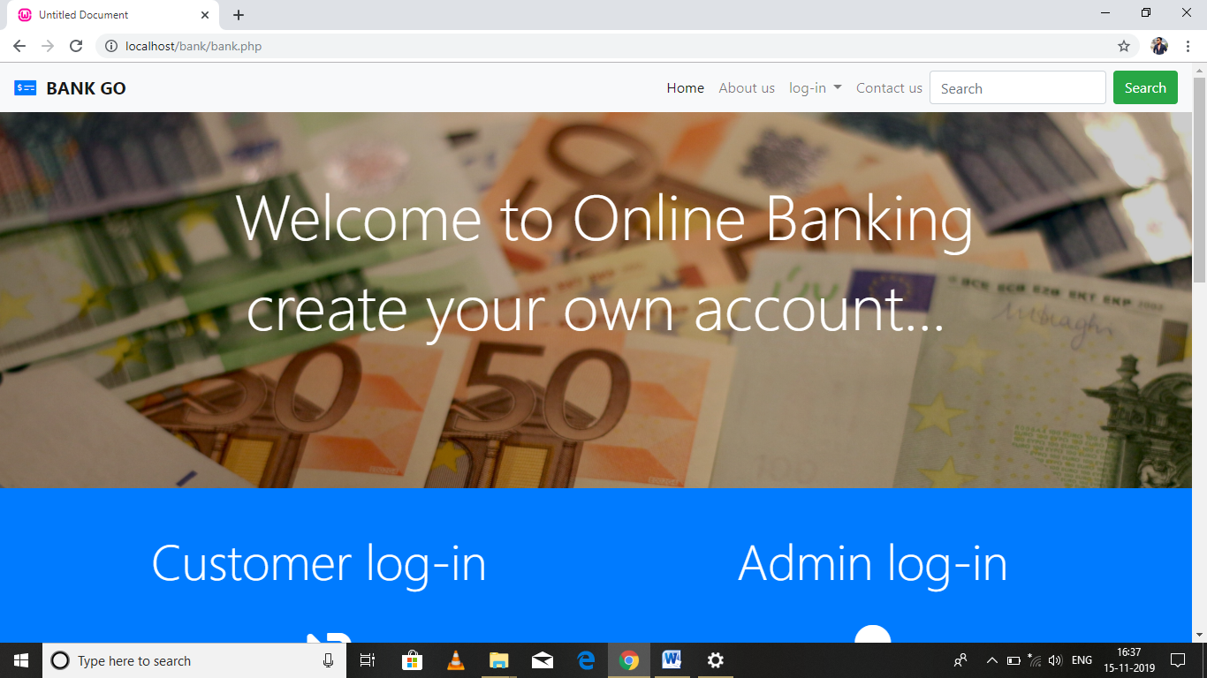

Fig 5.6: Bank.php

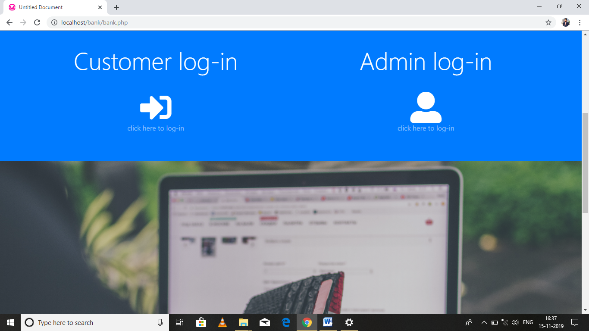

Fig 5.7: Bank.php

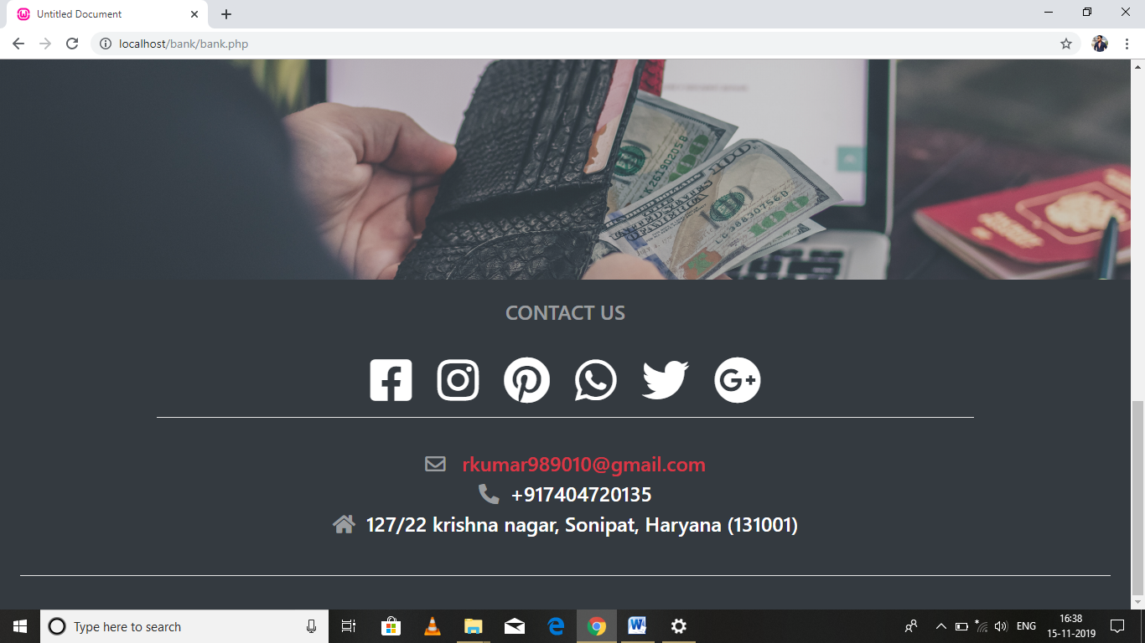

Fig 5.8:Bank.php

###### Main.php

###### 

Fig 5.9: main.php

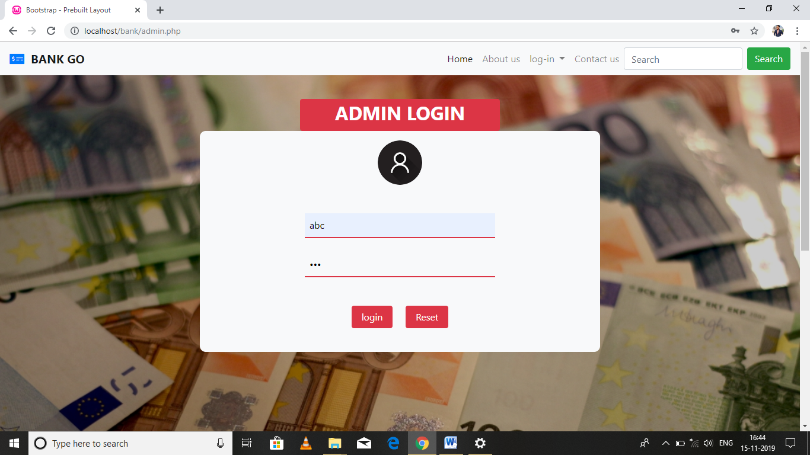

Fig 5.10: admin.php

**Register.php**

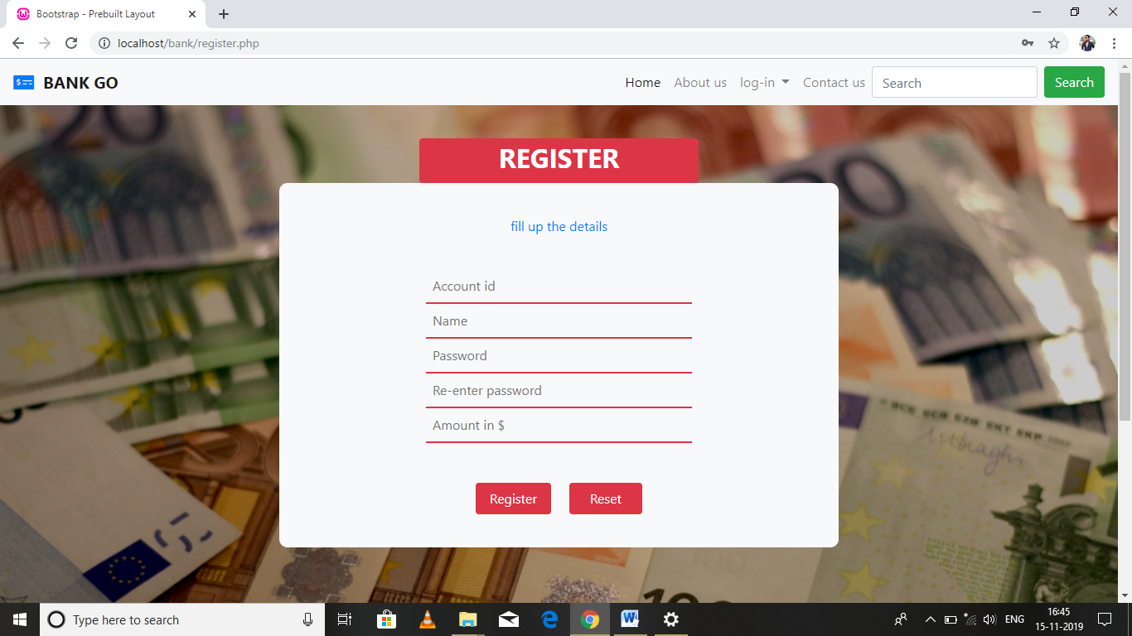

Fig 5.11: register.php

**Register_preview.php**

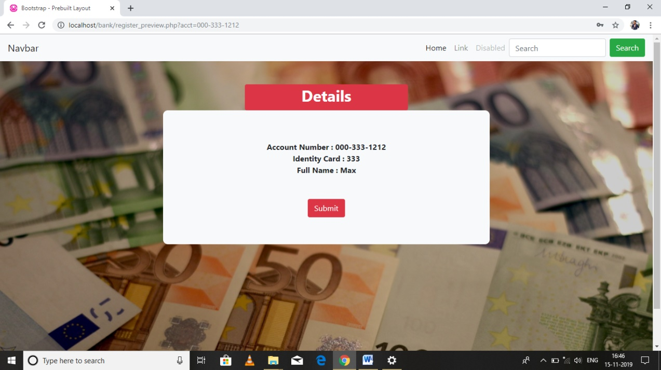

Fig 5.12: register_preview.php

**Transaction.php**

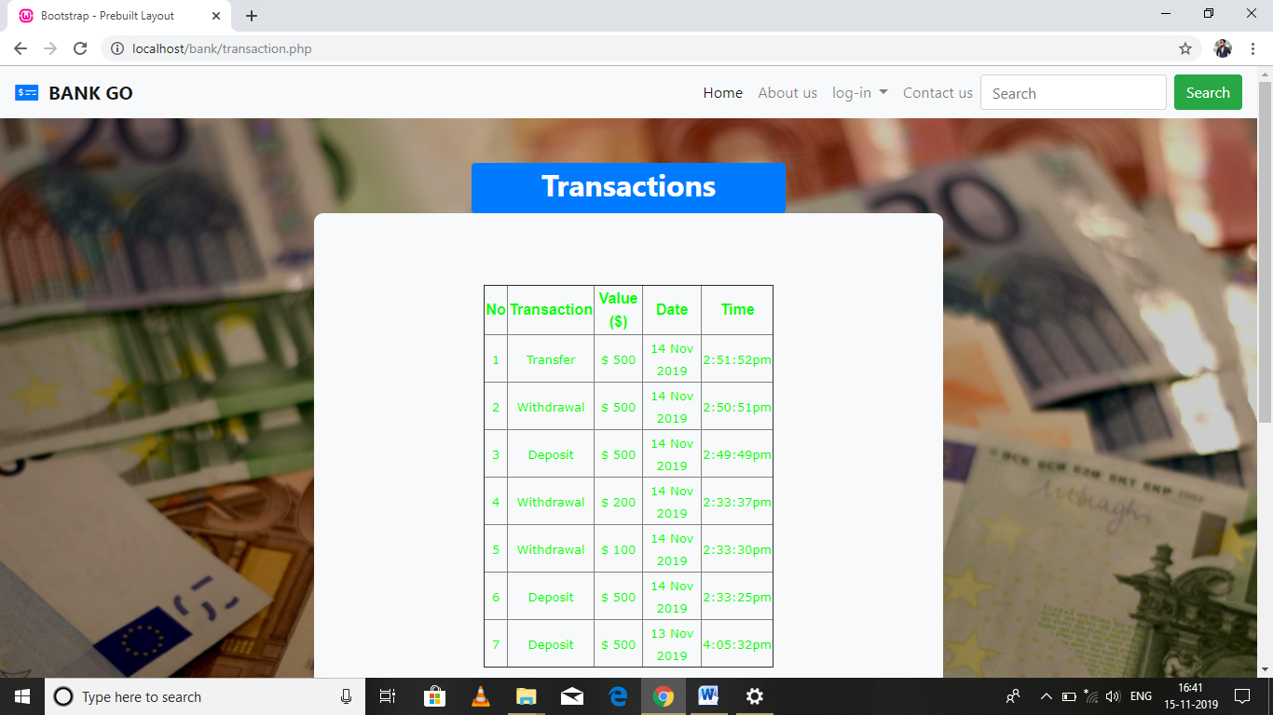

Fig 5.13: transaction.php

**Myacct.php**

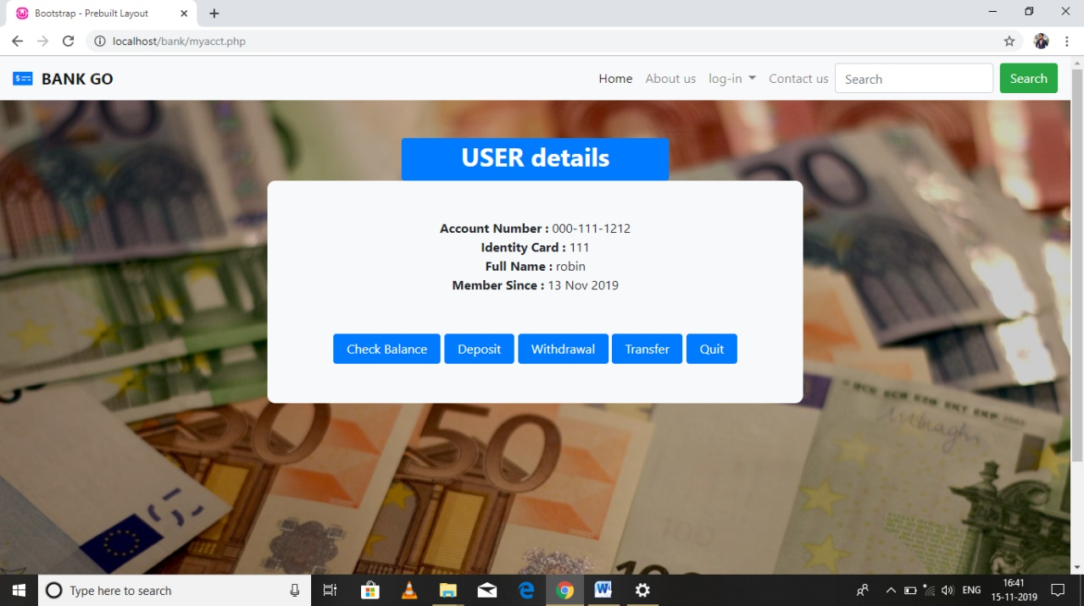

Fig 5.14: myacct.php

**Deposit.php**

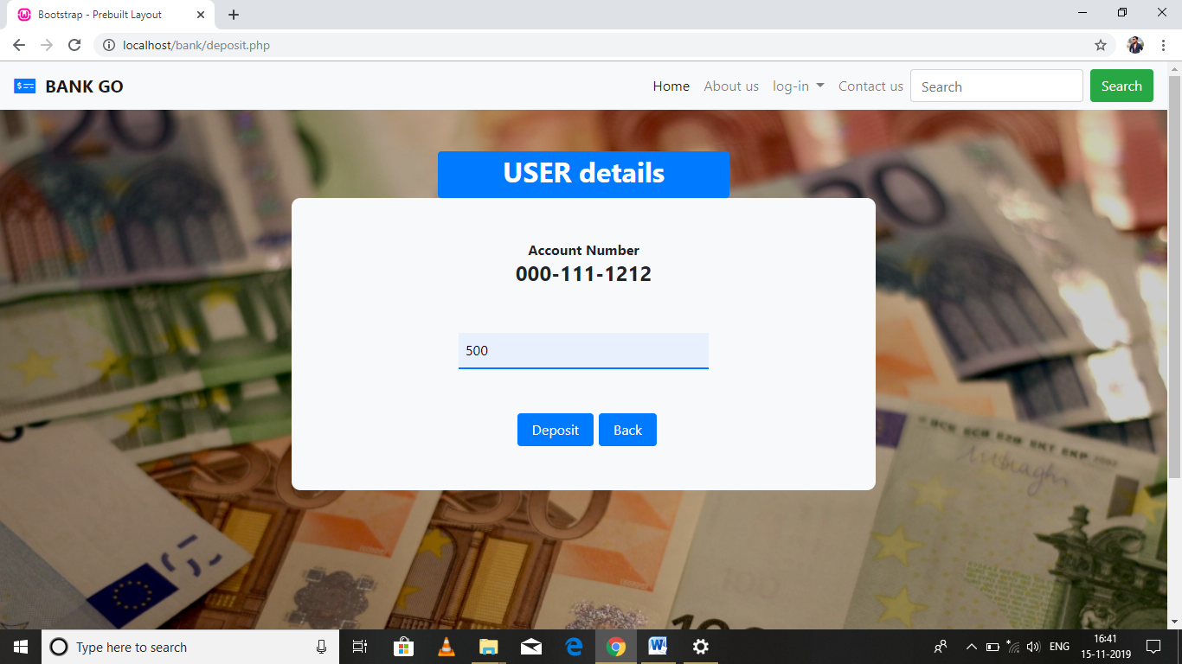

Fig 5.15: deposit.php

**balance.php**

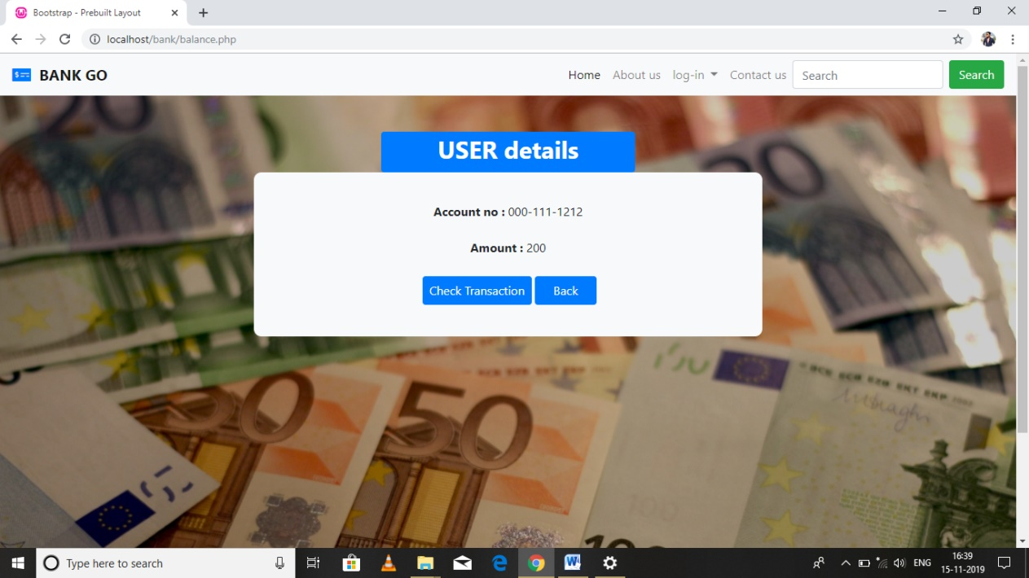

Fig 5.16: balance.php

**Withdrawal.php**

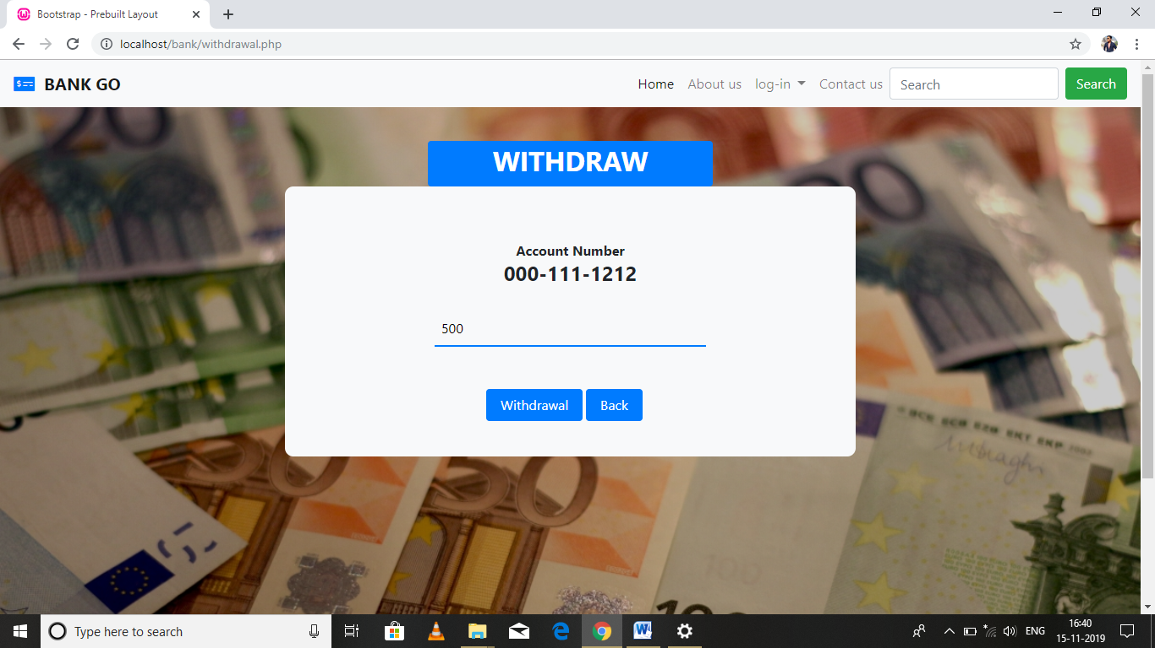

Fig 5.17: withdrawal.php

**transfer.php**

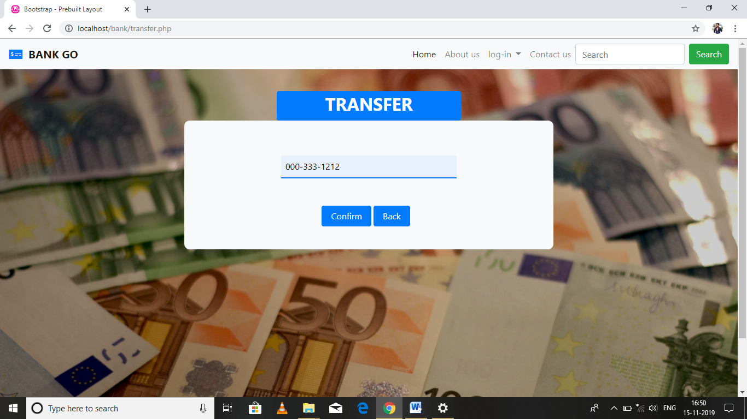

Fig 5.18: transfer.php

**Transfer2.php**

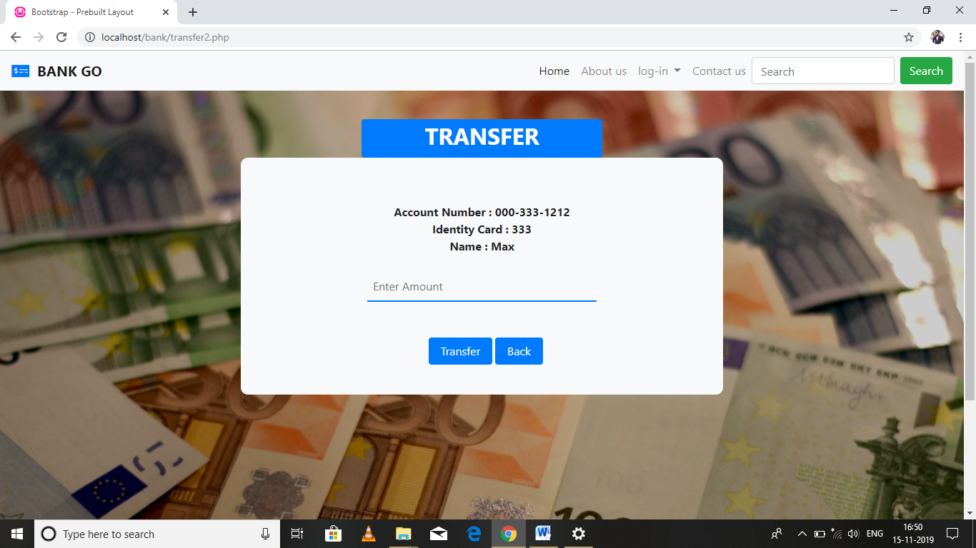

Fig 5.19: transfer2.php

# CHAPTER –6TESTING

Software“testing is any activity aimed at evaluating an attribute or capability of a program or system and determining that it meets its required results. Testing is a very important but an expensive activity. The purpose of testing can be quality assurance, verification and validation or reliability estimation.”

**Level of Testing:**

“Testing can be performed in following three levels.”

* + 1. Unit testing
    2. Integration testing
    3. System testing

**Unit Testing**

Each“program component is tested on its own, isolated from the other components in the system.Such testing, known as module testing, component testing or unit testing, verifies that the component functions properly with types of inputs expected from studying the component design.”

**Integrated Testing**

When“all collecting components have been unit tested, the next step is ensuring the interfaces among the components are defined and handled properly. Integration testing is the process of verifying that the system components work together as described in the system and program design specifications.”

**System Testing**

System testing“focuses on a complete, integrated system to evaluate compliance with specified requirements. Tests are made on characteristics that are only present when the entire system is run.”

## 6.1 TEST CASE DESIGN

The“design“of tests for software and other engineered products can be as challenging as the initial design of the product itself. Yet, for reasons that we have already discussed, software engineers often treat testing as an afterthought, developing test cases that may feel right but have little assurance of being complete. Recalling the objectives of testing, we must design tests that have the highest likelihood of finding the most errors with a minimum amount of time and effort.””

A“rich variety of test case design methods have evolved for software. These methods provide the developer with a systematic approach to testing. More important, methods provide a mechanism that can help to ensure the completeness of tests and provide the highest likelihood for uncovering errors in software.” “ “

## 6.2 Types of Testing

The first"test approach is called discovery testing and the second, white-box testing. At the point when program is considered, discovery testingalludes to tests that are led at the product interface. In spite of the fact that they are intended to reveal mistakes, discovery tests are utilized to show that product capacities are operational, that info is appropriately acknowledged and yield is effectively created, and that the honesty of outer data (e.g., a database) is kept up.”

A black-box test examines some fundamental aspect of a system with little regard for the internal logical structure of the software.

White-box testing“of software is predicated on close examination of procedural detail. Logical paths through the software are tested by providing test cases that exercise specific sets of conditions and/or loops. The "status of the program" may be examined at various points to determine if the expected or asserted status corresponds to the actual status.””

# CHAPTER – 7 SYSTEM IMPLEMENTATION

“

After having the user acceptance of the new system developed, the implementation phase begins. Implementation is the stage of a project during which theory is turned into practice. The major steps involved in this phase are:

* Acquisition and Installation of Hardware and Software
* Conversion
* User Training
* Documentation

The hardware and the relevant software required for running the system must be made fully operational before implementation. The conversion is also one of the most critical and expensive activities in the system development life cycle. The data from the old system needs to be converted to operate in the new format of the new system. The database needs to be setup with security and recovery procedures fully defined.

During this phase, all the programs of the system are loaded onto the user’s computer. After loading the system, training of the user starts. Main topics of such type of training are:

* How to execute the package?
* How to enter the data?
* How to process the data (processing details)?
* How to take out the reports?

After the users are trained about the computerized system, working has to shift from manual to computerized working. The process is called **Changeover**. The following strategies are followed for changeover of the system.””

1. **Direct Changeover:**This is the complete substitute of the old system by the new system. It is a risky approach and requires widespread system testing and exercise.
2. **Parallel run**: In parallel run both the systems, i.e., automated and manual, are executed at the same time for certain defined period. The same data is processed by both the systems. This strategy is less risky but more costly because of the following facts:

▪ Manual results can be compared with the results of the automated system.

▪ The functioning work is doubled.

▪ Failure of the automated system at the early stage does not affect the running of the organization, because the physical system continues to work, as it used to do.

1. **Pilot run**: In this kind of run, the new coordination is run with the data from one or more of the earlier periods for the whole or part of the system. The results are compared with the old system results. It is less expensive and risky than parallel run approach. This strategy builds the confidence and the errors are traced easily without affecting the operations.”

# 

# CHAPTER – 8 Documentation

The“documentation of the system is also one of the most important activities in the system development life cycle. This ensures the continuity of the system. Generally following two types of documentations are prepared for any system.”

* User or operative Documentation
* structure Documentation

## 8.1 Operational Document

The“system documentation contains the details of system design, programs, their coding, system flow, data dictionary, process description, etc. This helps to understand the system and permit changes to be made in the existing system to satisfy new user needs.”

## 8.2User Manual

The user“documentation is a complete description of the system from the user’s point of view detailing how to use or operate the system. It also includes the major error messages likely to be encountered by the user.”

# CHAPTER – 9 Conclusion& Future Scope

## 9.1 Conclusion

Banks“provide security and convenience for managing the money and sometimes allow you to make money by earning interest. Convenience and fees are two of the most important things to consider when choosing a bank. Writing and depositing cheques are perhaps the most fundamental way to move money in and out of a checking account, but advancements in technology have added ATM and debit card transactions. Advantages of using bank system over manual system:

1. Manual work takes more time and cost due to staff and other materials such as papers and registers.

2. Data retrieval process becomes easy when it is needed, if we use computer management instead of manually.

3. Storage capacity of the computer is also excellent.

4. Generating the invoice by printer using computer is also useful feature.

5. Updating of data is easy in computerized system.

6. Data consistency is required for neat and proper management that is achieved by computer easily.

7. With the help of software, data redundancy reduces as compared to manual.

**“**

## 9.2 Future Scope

**“**

It is not possible to develop a system that makes all the requirements of the user. User requirements keep changing as the system is being used. Some of the future enhancements that can be done to this system are:

**●** As the technology emerges, it is possible to upgrade the system and can be adaptable to desired environment.

**●** Because it is based on object-oriented design, any further changes can be easily adaptable.

**●** Based on the future security issues, security can be improved using emerging technologies.

**●** We can add module to deduct the amount on low balance in the account.

**●** We can add module to provide sms facility.

**●** We can add module to provide loan facility. “

# CHAPTER – 10 Bibliography& References

[1] The TUTORIALSPOINT website. [Online]. Available: http://

www.tutorialspoint.com/

[2] The GEEKSFORGEEKS website. [Online]. Available: http://

www.geeksforgeeks.com/

[3] W3school website [Online].Available: <https://www.w3schools.com/php/>

[4] Learning PHP, MySQL, JavaScript, CSS & HTML5: A Step-by-Step Guide to Creating Dynamic WebsitesBook by Robin Nixon